Created a new specflow project.
Downloaded Nuget packes i.e. Selenium web driver etc.
Based my folder and file structure off Kittens. Created application folder, started with Login class. Located relevant elements from Swag labs and created functions to veryify I am on the correct page and to log into the application. Then created inventory class and created a function to verify I am on the correct page after logging in.
Then created a feature file to log into the application. Then made the subsequent step definition classes for each page.
Then created a TestRunSettings.runsettings file for my cross browser testing. I then created a driver manager class to create the functionality for the cross browser testing and the set up and tear down of it. Which I could then call in my hooks class for my before and after scenarios.
The tests then worked fine in the test explorer, but dotnet test did not work, but ‘dotnet test --settings TestRunSettings.runsettings’ did. So I changed my projects csproj file and added the below for it to now work via ‘dotnet test’:
<Project Sdk="Microsoft.NET.Sdk">

<PropertyGroup>
<TargetFramework>net6.0</TargetFramework>
<Nullable>enable</Nullable>
<ImplicitUsings>enable</ImplicitUsings>

<!-- Add the RunSettingsFilePath property -->
<RunSettingsFilePath>$(MSBuildProjectDirectory)\TestRunSettings.runsettings</RunSettingsFilePath>
</PropertyGroup>
https://learn.microsoft.com/en-us/visualstudio/test/configure-unit-tests-by-using-a-dot-runsettings-file?view=vs-2022#set-a-build-property

Added the rest of my page classes, feature files, and step definitions. Implemented CSV file testing. Needed to download the specflow external data package so that this would work.

Adding extent reporting
- Go to framework in document explorer and add a folder called test results.
- Then make utility class for the structure of extent reports – add utility folder then add extent re[ort class inside it
- Using version 4.1, 5 doesn’t work with copied over code.
  - Created extent report class
  - Reference variables created with _names: Link to ‘Feature’ and ‘Scenarios@ in feature file.
  - Then ‘dir’ getting the directory of the current project.
  - Then replacing that particular part with the folder I created at the start.
  - Extent report init – path where to generate html report, then I’m setting a couple of values here. Then starting that particular object (building it by setting a couple of values).
  - Then created object of extent report. Then I’m passing some hard coded values.
  - Flush – push to extent report
- Added bits to hooks class
  - :ExtentReport – inherit that class

DOCKER
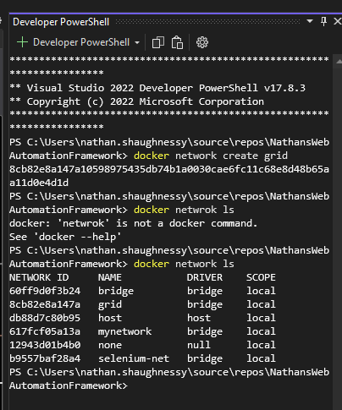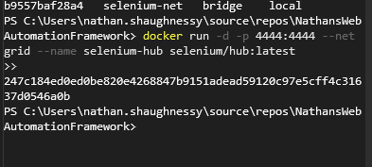

docker run -d -p 4444:4444 --net grid --name selenium-hub -v /dev/shm:/dev/shm selenium/node-chrome:3.141
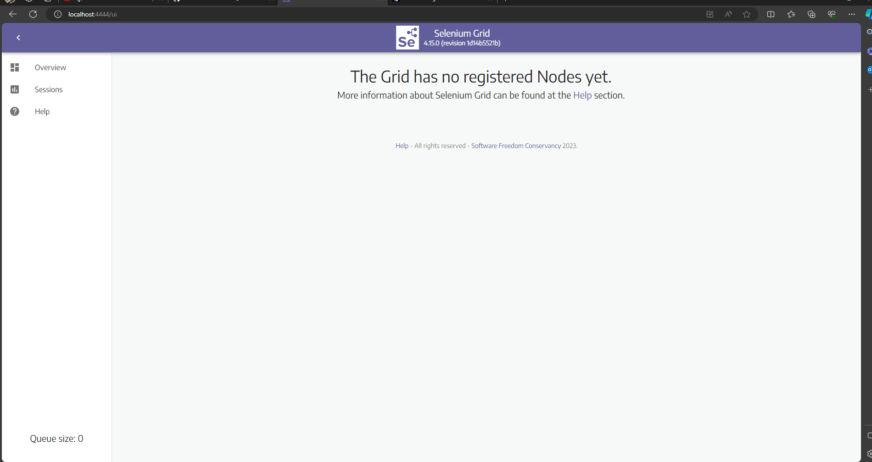

PS C:\Users\nathan.shaughnessy\source\repos\NathansWebAutomationFramework> docker network create grid
>>
8c82950be186f69b63cc436c3e249df8452a33b351f2b356fbc8965c1aeece07
PS C:\Users\nathan.shaughnessy\source\repos\NathansWebAutomationFramework> ^C
PS C:\Users\nathan.shaughnessy\source\repos\NathansWebAutomationFramework> docker run -d -p 4444:4444 --net grid --name selenium-hub selenium/hub:3.141.59-20210607
>>
Unable to find image 'selenium/hub:3.141.59-20210607' locally
3.141.59-20210607: Pulling from selenium/hub
da7391352a9b: Pull complete
14428a6d4bcd: Pull complete
2c2d948710f2: Pull complete
2b41b148e8ae: Pull complete
01e3b2f6507d: Pull complete
8a548a55533b: Pull complete
89ac7d26d4d6: Pull complete
b338d1b831e7: Pull complete
5020d0910108: Pull complete
8baf2da5beef: Pull complete
50fd3722e07d: Pull complete
ad5e5b21b7ec: Pull complete
541331a972d0: Pull complete
Digest: sha256:7461fde60dcb6e0ff0ef514fd16c39dc53638d57f05893ab33150eba9649cb51
Status: Downloaded newer image for selenium/hub:3.141.59-20210607
909401807bb3e5ea0cf20f021ffe396af553a3498bfb357e9bce454efb0eaaa3
PS C:\Users\nathan.shaughnessy\source\repos\NathansWebAutomationFramework> docker run -d --net grid -e HUB_HOST=selenium-hub -v /dev/shm:/dev/shm selenium/node-chrome:3.141.59-20210607
Unable to find image 'selenium/node-chrome:3.141.59-20210607' locally
3.141.59-20210607: Pulling from selenium/node-chrome
da7391352a9b: Already exists
14428a6d4bcd: Already exists
2c2d948710f2: Already exists
2b41b148e8ae: Already exists
01e3b2f6507d: Already exists
8a548a55533b: Already exists
89ac7d26d4d6: Already exists
b338d1b831e7: Already exists
5020d0910108: Already exists
8baf2da5beef: Already exists
442ffb0fafac: Pull complete
ad4ab56d9bcc: Pull complete
05ade3e471c3: Pull complete
001ec51ea75a: Pull complete
4bbc9ae246d1: Pull complete
97d8607f6ab3: Pull complete
c26c968351a1: Pull complete
06c65e13948b: Pull complete
4b7874e6f671: Pull complete
1f01212b0d59: Pull complete
9886db2f98c3: Pull complete
f7ab733ed9a7: Pull complete
Digest: sha256:af9c625f8a93907e83d5060680c8270959489ea66c7b18e3ae7a47b49729a0a5
Status: Downloaded newer image for selenium/node-chrome:3.141.59-20210607
4c6058604bd1e32c30eaf65049e7637e6982e664d32c975c10853fbbdd1acc73
PS C:\Users\nathan.shaughnessy\source\repos\NathansWebAutomationFramework> docker run -d --net grid -e HUB_HOST=selenium-hub -v /dev/shm:/dev/shm selenium/node-firefox:3.141.59-20210607
>>
Unable to find image 'selenium/node-firefox:3.141.59-20210607' locally
3.141.59-20210607: Pulling from selenium/node-firefox
da7391352a9b: Already exists
14428a6d4bcd: Already exists
2c2d948710f2: Already exists
2b41b148e8ae: Already exists
01e3b2f6507d: Already exists
8a548a55533b: Already exists
89ac7d26d4d6: Already exists
b338d1b831e7: Already exists
5020d0910108: Already exists
8baf2da5beef: Already exists
442ffb0fafac: Already exists
ad4ab56d9bcc: Already exists
05ade3e471c3: Already exists
001ec51ea75a: Already exists
4bbc9ae246d1: Already exists
97d8607f6ab3: Already exists
632358927370: Pull complete
eccc401a6a5b: Pull complete
36030c5d111d: Pull complete
f42e9aa8c0be: Pull complete
c2713b8aa241: Pull complete
Digest: sha256:be72ac7d20589614a55fa3bc8eed34d1ba0688890968c8fd1d2c81cd0da11de4
Status: Downloaded newer image for selenium/node-firefox:3.141.59-20210607
437224e169c244a3dfe0d47de3bda7ba2846c3f7fe24785e62659dd591f85889
PS C:\Users\nathan.shaughnessy\source\repos\NathansWebAutomationFramework>

